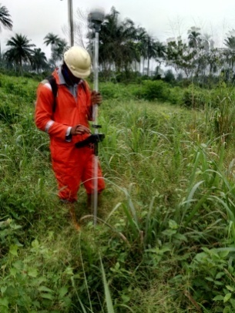
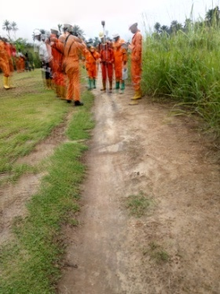

KM 18.2 AND KM 18.188 OBGI-RUMUEKPE EXPORT LINE

